Study protocol/design

Methods
This study uses a design-based approach (Brown, 1992; The Design-Based Research Collective, 2003), leveraging findings for refinements to the inquiry lessons and technology, and leading to design guidelines for supporting inquiry with immersive technology. We follow the arc of activity, from teachers designing to their students learning. This project brings together expertise in computer science, mathematics, teacher education, and learning sciences.

Participants and setting
We sought teacher participants from a spring 2012 course on project-based learning that was the subject of a related study focusing on teachers as designers. Although most of these participants were in-service K-12 teachers, the course also included a mathematics graduate student – Mr. D--who teaches math classes for pre-service elementary teachers. We decided to use his class for our first pilot study, reported here; additional studies with classroom teachers are in progress.
Mr. D has taught the class previously several times. Nine students consented to participate. Mr. D designed a three-day activity with feedback from the research team. He targeted arithmetic and geometric sequences, with one day spent in the dome. Our dome is a 15-ft diameter dome theater system that can accommodate about 12 people and employs six video projectors powered by one Mac Pro and tiled together to create a seamless image of about 2000x2000 pixels (Figure 2).
Mr. D worked with the computer scientist to make changes to an existing program for the dome; domestroids allows the user to navigate through space with a skateboard and use the Wii-mote to blow up asteroids. They modified the program to allow “snapshots” to be taken, to specify the number of pieces an asteroid could break into if hit, and to export data about the number of hits and number of asteroids present.
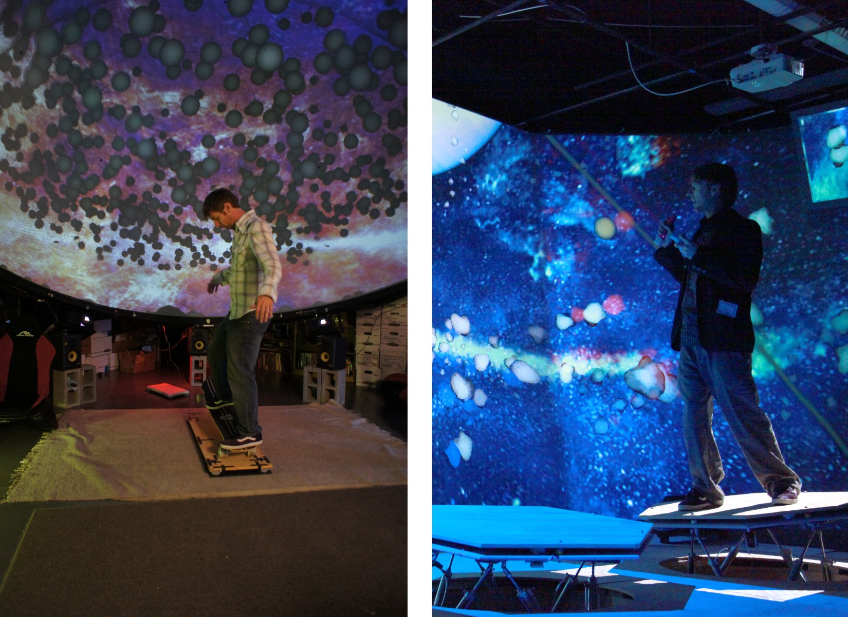
Figure 2. Novel control devices allow for interactivity, increasing presence when added to immersive technologies and opening up questions about the opportunity for increased learning. On the left, a physics simulation is controlled with a skateboard interface device. On the right, he flies through the rings of Saturn on a full-body haptics system – a ‘hex deck’ that has pneumatic cylinders creating force feedback while his motions control navigation.

Mr. D created a scenario for his students, “Mission: Armageddon,” in which asteroids threaten life on Earth; their task is to test a weapon proposed by a biologist who studies cell division (table 1). Students spent portions of three 50-minute class periods working in groups (table 2), with one class period in the dome.

Table. 1. Data students worked with prior to going to the dome. Data were presented as part of a data set that inspired a biologist to design a defensive weapon to protect the Earth from asteroid impacts by reliably dividing an asteroid into a specified number of pieces with each strike.
Number of data points collected | Time (minutes) | Cell Count | Number of cell divisions that have occurred
1 | 0 | 1 | 0
2 | 6 | 8 | 3
3 | 12 | 64 | 6
4 | 18 | 512 | 9
5 | 24 | 4,096 | 12

Table 2. Sequence of activities in Mission: Armageddon
Pre-dome session  (40 minutes) | Homework | Dome session  (50 minutes) | Homework | Post-dome session  (10 minutes)
Mr. D introduced Mission: Armageddon; students worked in groups on the cell division tasks | Students worked individually on the cell division tasks | Mr. D gave roles to the students; they practiced their roles; Mr. D guided them through the activity for first part, (15 min); remainder of time spent with the “lights up” and working together on developing a formula, while still sitting under the dome | Students worked individually on the remaining asteroid tasks | Mr. D gave a brief lecture on sequences, with class discussion

Data sources
In order to answer the research questions, various types of data were collected and analyzed (table 3). Video records were collected in accordance with field standards (Derry et al., 2010). Qualitative analysis, especially interaction analysis (Jordan & Henderson, 1995), was used audio/video records. Design artifacts were coded using a mixed approach, beginning with grounded coding, and followed with a design schema. Pre/post assignments were scored using a rubric developed by the teacher (table 4, inter-rater reliability is in progress).

Table 3. Data sources collected to answer the research questions
Data sources | Research questions
Emails and notes about design process | Q1
Audio recordings of design meetings | Q1
Interviews with the teacher | Q1, Q2
Designed lessons and materials | Q1, Q2
Field notes of class meetings | Q1, Q2
Video/audio recordings in the dome | Q1, Q2
Student work | Q2
Teacher grades and think-aloud about the grades | Q2
Teacher grades for other course activities | Q2

Table 4. Rubric for Mission: Armageddon, post-dome homework
Level (score) | description
High  9-10 | The student has a clear understanding of the concept of a sequence and can identify the pattern (either by using a visual model or by directly stating it as an expression) that is illustrated in the question. They have correctly answered the question “Why can there not be exactly 4,117 minimal sized asteroids at the end of the sequence?” They have also correctly written the entire formula (with possibly minor details missing) for the number of asteroids as a function of the number of strikes by the weapon.
Medium  7-8 | The student has some valid mathematical notions about sequences and the pattern but has missed some clarifying details. They have correctly answered (or have correct methods of answering) the question of “Why can there not be exactly 4,117 minimal sized asteroids at the end of the sequence?” They have written a formula that is mostly correct, but may lack some explanation of reasoning or have non-sequence-related mathematical errors or misinterpretations.
Basic  6-7 | The student has missed important details about sequences or the pattern but has made some non-trivial and mostly correct comments about sequences (or the pattern) in their work even if they are somewhat unrelated. They have made an attempt at the question of “Why can there not be exactly 4,117 minimal sized asteroids at the end of the sequence?” but their reasoning is unclear or incorrect. Formula is absent from their work or is incorrect.
Low  0-5 | The student did not attempt the problem set or failed to demonstrate appreciable knowledge about sequences. They do not understand or see the pattern and have failed to correctly answer the question of “Why can there not be exactly 4,117 minimal sized asteroids at the end of the sequence?” Formula may not be present. If a formula is present, it is not relevant and/or incorrect.

Interview questions
NOTE: these were planned but not used in 2012 pilot testing
Today is July 11, 2012 and this is (state your name) and I am interviewing (first name of participant).
Did you have a sense of “being there” in the virtual space?
When you think back about your experience, do you think of the virtual space more as images that you saw, or more as somewhere that you visited?
Consider your memory of being in the virtual space. How similar in terms of the structure of the memory is this to the structure of the memory of other places you have been today? By ‘structure of the memory’ consider things like the extent to which you have a visual memory of the virtual space, whether that memory is in color, the extent to which the memory seems vivid or realistic, its size, location in your imagination, the extent to which it is panoramic in your imagination, and other such structural elements.
Can you explain to me what you just did?
How does what you did today relate to what you did in class on Monday?
What feedback do you have for us?
Assuming you plan to become a teacher, would you be interested in having this type of technology in your classroom to teach history, science or math?
Can you imagine a way to use this technology with your students?
Imagine you were going to explain an arithmetic sequence to a child. What examples could you provide? What about a geometric sequence?

References
Brown, A. L. (1992). Design Experiments: Theoretical and Methodological Challenges in Creating Complex Interventions in Classroom Settings. The Journal of the Learning Sciences, 2(2), 141-178.
Derry, S., Pea, R., Barron, B., Engle, R., Erickson, F., Goldman, R., . . . Sherin, B. (2010). Conducting Video Research in the Learning Sciences: Guidance on Selection, Analysis, Technology, and Ethics. Journal of the Learning Sciences, 19(1), 3-53.
Jordan, B., & Henderson, A. (1995). Interaction Analysis: Foundations and Practice. Journal of the Learning Sciences, 4(1), 39 - 103.
The Design-Based Research Collective. (2003). Design-based research: An emerging paradigm for educational inquiry. Educational Researcher, 32(1), 5–8.

