We Can't Just Go Shooting Asteroids Like Space Cowboys: Teaching and Learning with Immersive, Interactive Projection
Vanessa Svihla¹, Matthew Dahlgren², Nicholas Kvam¹, Jeffrey Bowles¹, & Joe Kniss¹
¹University of New Mexico; ²Basis Charter School, Phoenix

Abstract
This paper presents initial findings from an on-going project to investigate teaching and learning with immersive, interactive projection technologies. We report a case study of how this technology was used to support teaching and learning of arithmetic and geometric sequences. Inquiry extended beyond the relatively brief immersive experience through a teacher-designed challenge: testing new defense systems designed to protect Earth from asteroids, developed based on notions of cell division. The teacher assigned roles to learners to scaffold their collaboration in the immersive environment. Students successfully transferred their understanding of sequences in the context of cell division to the asteroid context. They engaged mathematically within the immersive environment. Mixed methods findings are discussed, along with next steps in our on-going research.

Objectives
Our research team has the capacity to develop low-cost immersive, interactive projection kits for use in classrooms. We are interested in considering how our designs can transform corners of classrooms into the Rings of Saturn, carbon nanotubes, etc. In this paper, we present results from our pilot study, which sought to explore how immersive, interactive technology (Figure 1) might provide context for inquiry teaching and learning. To achieve these objectives, we are developing technology, codesigning projects with teachers, and studying implementations and student learning. We focus on investigating two research questions; here we primarily report data related to the second question:
Q1) How might we support teachers to design and implement inquiry in which context is provided using immersive, interactive technology?
Q2) In what ways might an immersive experience provide a context for inquiry learning, before, during, and after the experience?

Perspectives
We jointly explore how to support teachers as designers (Svihla, Kniss, et al., 2012) for these types of experiences (Svihla, Dahlgren, et al., 2012), their enactment of their designs, and how their students interact and learn.

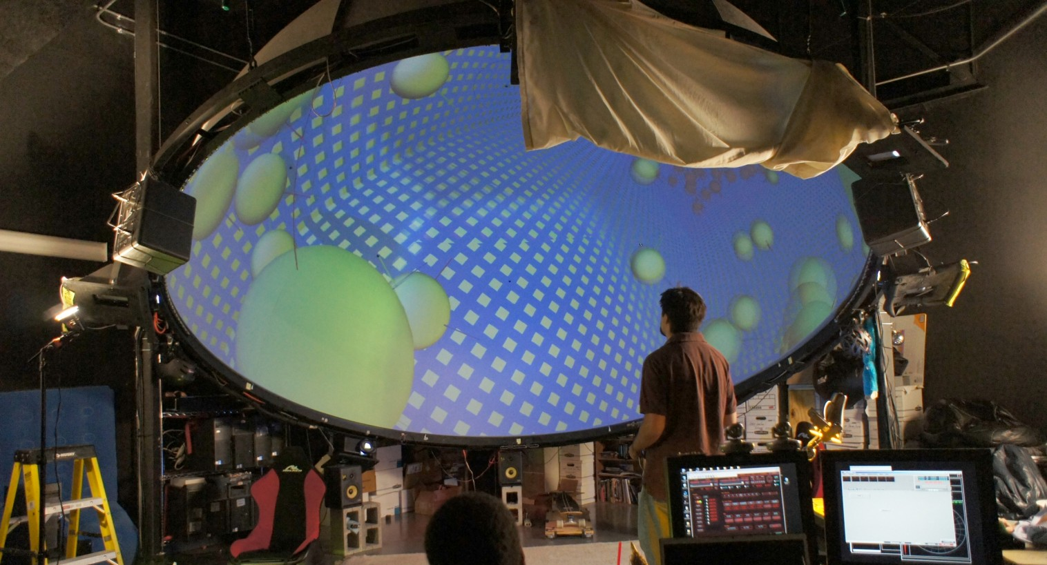
Figure 1. The dome system [at our institution] is a 15-foot diameter immersive media research facility employing six video projectors to create a high resolution image enveloping the audience’s vision. Here, a research assistant explores a simulation of a theoretical cooling system.

Teachers as designers
Research on teachers as designers in more general terms has resulted in mixed findings. Teachers’ design work has been framed in terms of out-of-class planning (Carlgren, 1999) and as a reflective process embedded in practice (Schön, 1983). In the former, this has typically occurred in one of three ways: professional development, formal coursework, or (semi-) professional curriculum development teams. As part of curriculum development teams it has been reported that teachers struggle to think like designers (Reiser et al., 2000). In courses and seminars (Koehler & Mishra, 2005a, 2005b; Koehler, Mishra, Hershey, & Peruski, 2004), success has been found when pedagogical problems are authentic and design process is iterative (Koehler & Mishra, 2005a, 2005b; Koehler et al., 2004).
In professional development approaches, there is evidence both that redesign of existing materials confers a benefit over design (Penuel & Gallagher, 2009), and that it does not (Cviko, McKenney, & Voogt, 2012). Related work has yielded the concept of pedagogical design capacity (M. Brown & Edelson, 2003), tying adaptations teachers make to instructional success. When teachers adapt existing curricula, their adaptations do not necessarily align to the intent of the original designs (Penuel & Yarnall, 2005), though this is not de facto a negative. Teachers struggle to design authentic assessments and to integrate technology effectively (Marx, Blumenfeld, Krajcik, & Soloway, 1997), especially in ways that support collaboration (Lakkala, Lallimo, & Hakkarainen, 2005).
There is evidence across contexts suggesting that design principles can help teachers to design successfully (Bybee, 1997; Edelson, 2001; Schwarz & Gwekwerere, 2007), but that if the principles are too general, providing curricula to adapt paired with professional development or educative materials can also be successful (Ball & Cohen, 1996; Connelly & Clandinin, 1988; Davis & Krajcik, 2005; Fishman, Marx, Best, & Tal, 2003; Schneider & Krajcik, 2002). Our approach includes providing design principles and design tools (Svihla, Kniss, et al., 2012), asking teachers to redesign their own curricula to meet identified needs, and guiding this process.

Learning with immersive media
Virtual learning environments enhance learning when they offer a situated experience (Dede, 2009), which is an effective inquiry approach (Rivet & Krajcik, 2008). Although little research has explored the use of immersive projection technologies for learning (Apostolellis & Daradoumis, 2010), studies have found benefits for viewing immersive displays in terms of recall (e.g., Sumners, Reiff, & Weber, 2008). Open questions about the role of immersive environments for learning remain; in particular, Dede (2009) highlights that research is needed on supporting transfer by blending learning across virtual and real settings. We consider the arc of learning activity, exploring how learners proceeded through real and projected settings.

Methods
This study uses a design-based approach (A. L. Brown, 1992; The Design-Based Research Collective, 2003), leveraging findings for refinements to the inquiry lessons and technology, and leading to design guidelines for supporting inquiry with immersive technology. We follow the arc of activity, from teachers designing to their students learning. This project brings together expertise in computer science, mathematics, teacher education, and learning sciences.

Participants and setting
We sought teacher participants from a spring 2012 course on project-based learning that was the subject of a related study focusing on teachers as designers. Although most of these participants were in-service K-12 teachers, the course also included a mathematics graduate student – Mr. D--who teaches math classes for pre-service elementary teachers. We decided to use his class for our first pilot study, reported here; additional studies with classroom teachers are in progress.
Mr. D has taught the class previously several times. Nine students consented to participate. Mr. D designed a three-day activity with feedback from the research team. He targeted arithmetic and geometric sequences, with one day spent in the dome. Our dome is a 15-ft diameter dome theater system that can accommodate about 12 people and employs six video projectors powered by one Mac Pro and tiled together to create a seamless image of about 2000x2000 pixels (Figure 2).
Mr. D worked with the computer scientist to make changes to an existing program for the dome; domestroids allows the user to navigate through space with a skateboard and use the Wii-mote to blow up asteroids. They modified the program to allow “snapshots” to be taken, to specify the number of pieces an asteroid could break into if hit, and to export data about the number of hits and number of asteroids present.

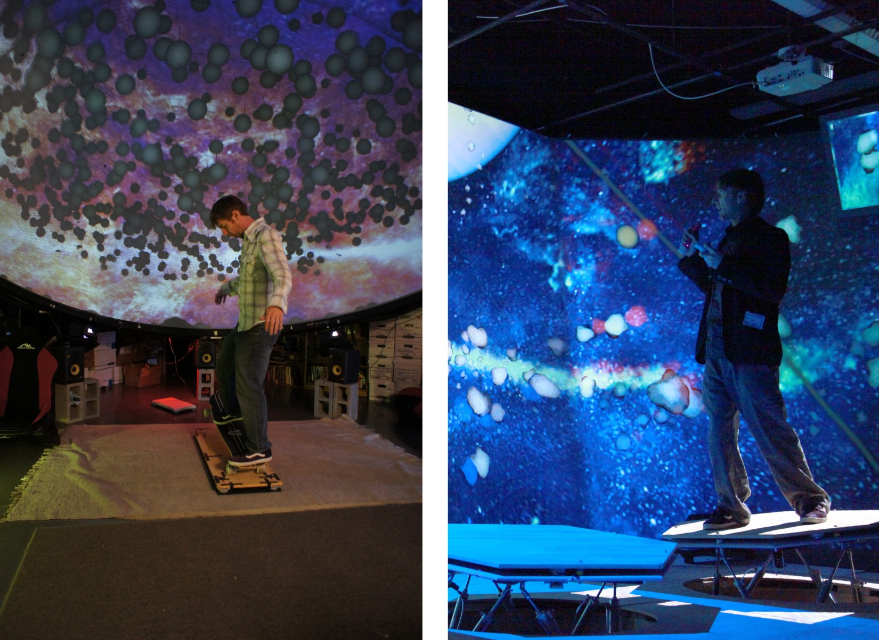
Figure 2. Novel control devices allow for interactivity, increasing presence when added to immersive technologies and opening up questions about the opportunity for increased learning. On the left, a physics simulation is controlled with a skateboard interface device. On the right, he flies through the rings of Saturn on a full-body haptics system – a ‘hex deck’ that has pneumatic cylinders creating force feedback while his motions control navigation.

Mr. D created a scenario for his students, “Mission: Armageddon,” in which asteroids threaten life on Earth; their task is to test a weapon proposed by a biologist who studies cell division (table 1). Students spent portions of three 50-minute class periods working in groups (table 2), with one class period in the dome.

Table. 1. Data students worked with prior to going to the dome. Data were presented as part of a data set that inspired a biologist to design a defensive weapon to protect the Earth from asteroid impacts by reliably dividing an asteroid into a specified number of pieces with each strike.
Number of data points collected | Time (minutes) | Cell Count | Number of cell divisions that have occurred
1 | 0 | 1 | 0
2 | 6 | 8 | 3
3 | 12 | 64 | 6
4 | 18 | 512 | 9
5 | 24 | 4,096 | 12

Table 2. Sequence of activities in Mission: Armageddon
Pre-dome session  (40 minutes) | Homework | Dome session  (50 minutes) | Homework | Post-dome session  (10 minutes)
Mr. D introduced Mission: Armageddon; students worked in groups on the cell division tasks | Students worked individually on the cell division tasks | Mr. D gave roles to the students; they practiced their roles; Mr. D guided them through the activity for first part, (15 min); remainder of time spent with the “lights up” and working together on developing a formula, while still sitting under the dome | Students worked individually on the remaining asteroid tasks | Mr. D gave a brief lecture on sequences, with class discussion

Data sources
In order to answer the research questions, various types of data were collected and analyzed (table 3). Video records were collected in accordance with field standards (Derry et al., 2010). Qualitative analysis, especially interaction analysis (Jordan & Henderson, 1995), was used audio/video records. Design artifacts were coded using a mixed approach, beginning with grounded coding, and followed with a design schema. Pre/post assignments were scored using a rubric developed by the teacher (table 4, inter-rater reliability is in progress).

Table 3. Data sources collected to answer the research questions
Data sources | Research questions
Emails and notes about design process | Q1
Audio recordings of design meetings | Q1
Interviews with the teacher | Q1, Q2
Designed lessons and materials | Q1, Q2
Field notes of class meetings | Q1, Q2
Video/audio recordings in the dome | Q1, Q2
Student work | Q2
Teacher grades and think-aloud about the grades | Q2
Teacher grades for other course activities | Q2

Table 4. Rubric for Mission: Armageddon, post-dome homework
Level (score) | description
High  9-10 | The student has a clear understanding of the concept of a sequence and can identify the pattern (either by using a visual model or by directly stating it as an expression) that is illustrated in the question. They have correctly answered the question “Why can there not be exactly 4,117 minimal sized asteroids at the end of the sequence?” They have also correctly written the entire formula (with possibly minor details missing) for the number of asteroids as a function of the number of strikes by the weapon.
Medium  7-8 | The student has some valid mathematical notions about sequences and the pattern but has missed some clarifying details. They have correctly answered (or have correct methods of answering) the question of “Why can there not be exactly 4,117 minimal sized asteroids at the end of the sequence?” They have written a formula that is mostly correct, but may lack some explanation of reasoning or have non-sequence-related mathematical errors or misinterpretations.
Basic  6-7 | The student has missed important details about sequences or the pattern but has made some non-trivial and mostly correct comments about sequences (or the pattern) in their work even if they are somewhat unrelated. They have made an attempt at the question of “Why can there not be exactly 4,117 minimal sized asteroids at the end of the sequence?” but their reasoning is unclear or incorrect. Formula is absent from their work or is incorrect.
Low  0-5 | The student did not attempt the problem set or failed to demonstrate appreciable knowledge about sequences. They do not understand or see the pattern and have failed to correctly answer the question of “Why can there not be exactly 4,117 minimal sized asteroids at the end of the sequence?” Formula may not be present. If a formula is present, it is not relevant and/or incorrect.

Results

Supporting teachers as designers
Q1) How might we support teachers to design and implement inquiry in which context is provided using immersive, interactive technology?
We address these findings in greater depth elsewhere, but report findings relevant to understanding the complex of teaching and learning interactions that occurred. In brief, iteration was important, as were team discussions about how the immersive media might be incorporated. The teacher identified two specific needs he wished to address: students’ fear of math; and a topic that had been difficult to teach in past. He viewed the “worst case” as the students not learning, but at least not adding to their feelings of failure.
The teacher reflected that he felt more invested in the activity because of his role in designing it. He explained that he felt more able to respond and adapt when something unexpected happened. For example, although he aimed to create an activity that only included arithmetic and geometric sequences, the homework he gave actually required understanding of mathematical series. He did not recognize this—and reported confusion as to why the students had struggled on that particular part of the homework; however, once in the dome, he was able to pose questions and provide feedback, which led him to identify this as their source of confusion (he wrote “This is actually a series” on the activity and showed it to us) and then to adapt his questions.
Mr. D reflected on the activity as being “efficient,” because, "If I were to teach the same topic in class, in order to achieve the same level of understanding, I think I would have had to spend three or four days using traditional instruction methods.[…] I have attempted to teach this topic in the past (over the course of two days) and come away from it feeling as though the instruction was not successful."

Providing context for inquiry
In what ways might an immersive experience provide context for inquiry learning, before, during, and after the experience?
The pre-dome session was similar to Mr. D’s other class sessions; students worked in groups solving mathematical tasks. Gabriela, as usual, emerged as a leader in her group, quickly reaching correct answers and guiding her group mates through the tasks.
The dome session began with Mr. D handing out the next part of their “mission” and asking for volunteers for various roles (e.g., gunner, pilot, data collectors), assigning roles if no one volunteered. He then gave them a few minutes to practice their roles, including learning to navigate with the skateboard, figuring out what data to record, and blasting asteroids. He then asked a student to read the first question, and as a group they began trying to figure out the answers. It took several minutes for the group to learn to coordinate (e.g., the gunner was quicker at destroying asteroids than the data recorders were at documenting the results). After 15 minutes, Mr. D interjected, “We gotta be systematic about this though. We can't just go shooting-- shooting asteroids like space cowboys, right.”
Throughout the first part of the session, Mr. D guided students through their mission with prompts that helped them to notice specific aspects of the immersive media, such as how many strikes it took to break the asteroids up into small enough pieces, or how many pieces resulted from each strike (e.g., transcript 1, turns 1-5).
We see an important transition point occurring when Ignacio (transcript 1, turn 6) answers one of these questions by instead posing his own question about whether there would “be a formula.” We see this as a critical moment for two reasons: 1) it demarks a change from Mr. D asking primarily asking procedural questions to primarily prompting the group to help each other (e.g., transcript 1, turn 12, and elsewhere in the corpus, figure 3); and 2) whereas Gabriella had frequently emerged as a leader, Ignacio generally struggled. In this context, however, he both transitioned the class from “shooting asteroids like space cowboys” to engaging more deeply with the math and ultimately led the class to write an abstract formula.

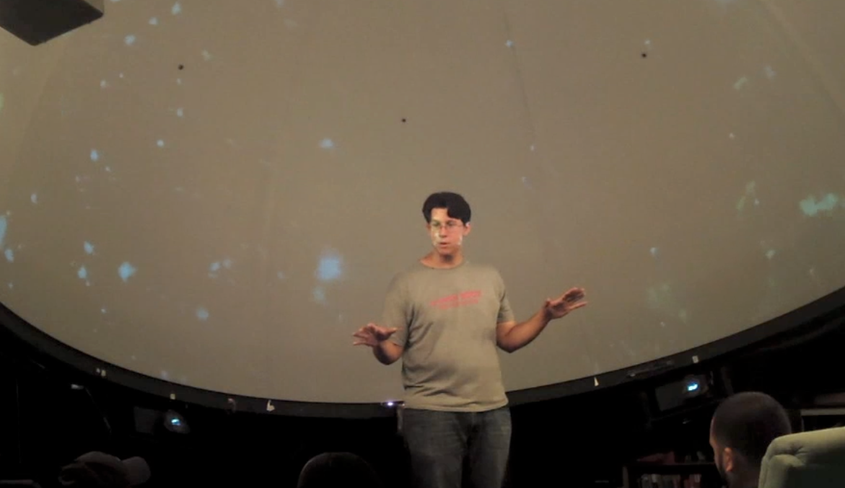
Figure 3. Mr. D guiding his class, seated in game chairs, with the “lights up” but interactive project still running.
In the post-dome session, Mr. D gave a lecture about the content, referencing specific examples in the dome; students engaged actively.
Transcript 1. Mr. D guiding students to notice how many pieces of asteroids are present after each strike. Ss indicates multiple students responded.

1 Mr. D: Wull:: cause one became three right so actually we only added (.)
2 Ss: Two
3 Mr. D: Two more so how many did we have?
4 Ss: 22
5 Mr. D: 22. Okay and then we did it again. We fired again. How many did we have after that?
6 Ignacio: So would there be a formula would be like uh the number of asteroids minus (.) minus one when it splits into three
7 Mr. D: You're getting kind of the right ide-. I'm not sure what you're saying
8 Ignacio: Minus one times two
9 Mr. D: No not times two //
10 Ignacio: //plus two
11 Mr. D: (.) You're almost there you're almost there.
12 Mr. D: Can anybody help him out. What do you guys think the formula for this thing should be.
Student work shows evidence of their learning (figure 4). Previously, whereas ~10% demonstrated higher than basic understanding, in this case, over 60% did so. On the pre-dome assignment, several students incorrectly treated geometric sequences as proportions, but on the post-dome assignment none did this. Over half of the students included visual representations in their post-dome assignments to demonstrate their understanding of sequence (figure 5).

Figure 4. Level of understanding demonstrated in the post-dome session homework
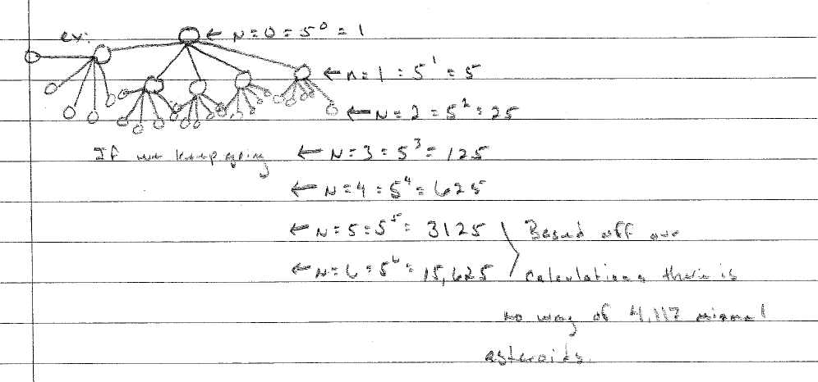
Figure 5. Ignacio’s post-dome representation of his algebraic expression, “number of asteroids =5^{(N)}”

Finally, we examine the variance in scores. Although the standard deviation for the dome-related work was higher than other assignments (table 5), we could not detect a pattern to this; for instance, role assignment did not correspond to performance. Further analysis and studies will examine engagement tied to learning.

Table 5. Descriptives for Mission: Armageddon and other assignments.
 | Mean  (out of 10) | Standard Deviation
Assignment 5 | 8.39 | 0.86
Assignment 6 | 9.50 | 0.43
Assignment 7 | 8.38 | 1.60
Assignment 8 | 7.43 | 1.43
Assignment 9 | 7.89 | 1.34
Assignment 10 | 9.28 | 0.79
Mission: Armageddon Pre | 7.50 | 1.38
Mission: Armageddon Post | 8.08 | 1.77
Assignment 12 | 8.33 | 1.46
Assignment 13 | 8.28 | 0.91
Assignment 14 | 9.11 | 0.86
Assignment 15 | 9.28 | 0.91

Scholarly significance
In this pilot study, we provide initial evidence for how a teacher-designed activity might leverage affordances of immersive, interactive projection. The experience created a “time for telling,” (Schwartz & Bransford, 1998) in which students were actively engaged in a lecture. Preliminary analysis indicates that the experience also reconfigured inquiry, allowing a student who seldom participated to emerge as a leader. Because of the exploratory nature of this work, we find that while we see strengths in the teacher’s design and evidence of inquiry learning, questions are raised offering a rich path forward in this on-going research. We cannot disambiguate the relative utility of the technology; on-going studies draw comparisons between immersive and non-immersive versions of activities, explore how roles might impact learning in this context; and investigate teachers-as-designers in K-12 settings.

References
Apostolellis, P., & Daradoumis, T. (2010). Exploring Learning through Audience Interaction in Virtual Reality Dome Theaters. Knowledge Management, Information Systems, E-Learning, and Sustainability Research, 444-448.
Ball, D. L., & Cohen, D. K. (1996). Reform by the Book: What Is: Or Might Be: The Role of Curriculum Materials in Teacher Learning and Instructional Reform? Educational Researcher, 25(9), 6-14.
Brown, A. L. (1992). Design Experiments: Theoretical and Methodological Challenges in Creating Complex Interventions in Classroom Settings. The Journal of the Learning Sciences, 2(2), 141-178.
Brown, M., & Edelson, D. (2003). Teaching as design: Can we better understand the ways in which teachers use materials so we can better design materials to support their changes in practice Design Brief. Evanston, IL: Center for Learning Technologies in Urban Schools.
Bybee, R. W. (1997). Achieving scientific literacy: From purposes to practices. Westport, CT: Heinemann.
Carlgren, I. (1999). Professionalism and teachers as designers. Journal of curriculum studies, 31(1), 43-56.
Connelly, F. M., & Clandinin, D. J. (1988). Teachers as Curriculum Planners. Narratives of Experience: Teachers College Press, 1234 Amsterdam Ave., New York, NY 10027.
Cviko, A., McKenney, S., & Voogt, J. (2012). Teachers as (re-) designers of an ICT-rich learning environment for early literacy.
Davis, E. A., & Krajcik, J. S. (2005). Designing educative curriculum materials to promote teacher learning. Educational Researcher, 34(3), 3-14.
Dede, C. (2009). Immersive interfaces for engagement and learning. Science, 323(5910), 66.
Derry, S., Pea, R., Barron, B., Engle, R., Erickson, F., Goldman, R., . . . Sherin, B. (2010). Conducting Video Research in the Learning Sciences: Guidance on Selection, Analysis, Technology, and Ethics. Journal of the Learning Sciences, 19(1), 3-53.
Edelson, D. (2001). Learning-for-use: A framework for the design of technology-supported inquiry activities. Journal of Research in Science Teaching, 38(3).
Fishman, B., Marx, R., Best, S., & Tal, R. (2003). Linking teacher and student learning to improve professional development in systemic reform. Teaching and Teacher Education, 19(6), 643-658.
Jordan, B., & Henderson, A. (1995). Interaction Analysis: Foundations and Practice. Journal of the Learning Sciences, 4(1), 39 - 103.
Koehler, M. J., & Mishra, P. (2005a). Teachers learning technology by design. Journal of Computing in Teacher Education, 21(3), 94-102.
Koehler, M. J., & Mishra, P. (2005b). What happens when teachers design educational technology? The development of technological pedagogical content knowledge. Journal of Educational Computing Research, 32(2), 131-152.
Koehler, M. J., Mishra, P., Hershey, K., & Peruski, L. (2004). With a little help from your students: A new model for faculty development and online course design. Journal of Technology and Teacher Education, 12(1), 25-56.
Lakkala, M., Lallimo, J., & Hakkarainen, K. (2005). Teachers' pedagogical designs for technology-supported collective inquiry: A national case study. Computers & Education, 45(3), 337-356.
Marx, R. W., Blumenfeld, P. C., Krajcik, J. S., & Soloway, E. (1997). Enacting project-based science. The Elementary School Journal, 341-358.
Penuel, W. R., & Gallagher, L. P. (2009). Preparing Teachers to Design Instruction for Deep Understanding in Middle School Earth Science. Journal of the Learning Sciences, 18(4), 461 - 508.
Penuel, W. R., & Yarnall, L. (2005). Designing handheld software to support classroom assessment: Analysis of conditions for teacher adoption. The Journal of Technology, Learning and Assessment, 3(5).
Reiser, B. J., Spillane, J. P., Steinmuller, F., Sorsa, D., Carney, K., & Kyza, E. (2000). Investigating the mutual adaptation process in teachers’ design of technology-infused curricula. In B. Fishman & S. O'Connor-Divelbiss (Eds.), Proceedings of the Fourth International Conference of the Learning Sciences (pp. 342-349). Mahwah, NJ: Erlbaum.
Rivet, A. E., & Krajcik, J. S. (2008). Contextualizing instruction: Leveraging students' prior knowledge and experiences to foster understanding of middle school science. Journal of Research in Science Teaching, 45(1), 79-100.
Schneider, R. M., & Krajcik, J. (2002). Supporting science teacher learning: The role of educative curriculum materials. Journal of Science Teacher Education, 13(3), 221-245.
Schön, D. A. (1983). The Reflective Practitioner: How Professionals Think in Action. New York: Basic Books.
Schwartz, D. L., & Bransford, J. D. (1998). A Time for Telling. Cognition and Instruction, 16(4), 475-522.
Schwarz, C. V., & Gwekwerere, Y. N. (2007). Using a guided inquiry and modeling instructional framework (EIMA) to support preservice K‐8 science teaching. Science Education, 91(1), 158-186.
Sumners, C., Reiff, P., & Weber, W. (2008). Learning in an immersive digital theater. Advances in Space Research, 42(11), 1848-1854.
Svihla, V., Dahlgren, M., Kvam, N., Kniss, J., Waldschmidt, E. D., Beining, D., . . . Hagerman, A. (2012, July 2nd). Supporting Practice, Integrating Research in Immersive Technologies into Educational Designs (SPIRITED): Technology to Support Co-located Collaborative Learning. Paper presented at the ICLS 2012 pre-conference workshop, Digital Ecosystems for Collaborative Learning: Embedding Personal and Collaborative Devices to Support Classrooms of the Future (DECL), Sydney.
Svihla, V., Kniss, J., Waldschmidt, E. D., Beining, D., Strawn, J., & Hagerman, A. (2012, July 3rd). Supporting Practice, Integrating Research in Immersive Technologies into Educational Designs (SPIRITED): Teachers as Designers. Paper presented at the ICLS 2012, pre-conference workshop, Teachers as Designers of Technology Enhanced Learning Materials, Sydney, Australia.
The Design-Based Research Collective. (2003). Design-based research: An emerging paradigm for educational inquiry. Educational Researcher, 32(1), 5–8.

Acknowledgements
This research is supported by an Interdisciplinary Research grant from the College of Education in cooperation with the Office of the Provost, University of New Mexico. We also acknowledge prior NSF funding (PFI #917919) for the technology development, though the views presented are our own.

